**CSS and CSS 3**

* **What are the benefits of using CSS?**
* CSS is used to style the HTML file. We can separate the content and its presentation.
* We can style the content in groups. So it saves so much time.
* We can style different pages with a single CSS file. So we can say that the CSS file is consistent in nature.
* We can change content size, color, background color, font-family globally rather than editing each element.
* **What are the disadvantages of CSS?**
* We have to master selectors, pseudo selectors, properties, values and box models and remember them to learn CSS. So it consumes time and resources to learn CSS.
* CSS sometimes lead to occur styling problems. Mostly specificity and order of applied styles lead to such problems.
* If websites are big then maintenance of CSS file become complex and time consuming. It is difficult to maintain naming and remembering all names to style the elements in groups. And it becomes time consuming when different types of content are to style differently.
* **What is the difference between CSS2 and CSS3?**
* The main difference is that there were no Media Queries, Animations, etc. in the CSS2 that are included in CSS3.
* CSS2 introduced box model while CSS3 introduced flexible box layout module, which allows for more flexible layouts.
* **Name a few CSS style components.**
* A CSS style consists of a selector and a declaration block. The selector is used to identify the element which is to be used to style and a declaration block contains properties and their values such as color, font size, margin, padding etc.

Ex. h1 {

Color: blue;

Font-size: 24px;

}

* Here h1 is selector, color & font-size are properties and blue & 24px are their property values.
* **What do you understand by CSS opacity?**
* CSS opacity is a property used to adjust the transparency of the content. It can adjust the transparency of any content like video, images, text, color, background color, etc.
* It can hide the content behind the other content.
* Its value can be given from 0 to 1 or it can be given by percentages also.
* There are other values too like inherit, initial, revert, revert-layer and unset.
* **How can the background color of an element be changed?**
* There is a property called ‘background-color’ you can use to change the background color of an element.
* There are three ways to change background-color such as changing it in particular element or in internal style tag or in external style sheet.

Ex. 1) Inline CSS

<body style="background-color:#33475b">

2) External CSS

body { background-color: #DBF9FC; }

* **How can image repetition of the backup be controlled?**
* To control image repetition of the backup use background-repeat named property and give it no-repeat value.
* **What is the use of the background-position property?**
* The background-position is used to set the position of a background image.
* Use background-position property and give it value in pixels, percentages or in name such as 50px 150px, 50% 50% or center center respectively where first value is for horizontal position and second value is for vertical position.
* **Which property controls the image scroll in the background?**
* The background-attachment property controls the image scroll in the background. It specifies whether the image will scroll along page or it will stay fixed in the page.
* The background-attachment property can be given either scroll value or fixed value.
* **Why should background and color be used as separate properties?**
* The separation of the background and color properties in CSS allows for greater flexibility when styling elements. With separate properties, users can easily modify background and color property independently.
* **How to center block elements using CSS1?**
* To horizontally center a block element like <div>, use margin: auto;
* **How to maintain the CSS specifications?**
* The CSS specifications are maintained by World Wide Web Consortium (W3C).
* Even though every browser supports CSS, there are many inconsistencies in in the specification version. Some browsers even have their own implementation of the specification and have proprietary prefixes.
* **What are the ways to integrate CSS as a web page?**
* Developer can add CSS to HTML in three different ways.
* First is by styling a single HTML element on the page, use inline CSS in a style attribute.
* Second is by adding CSS to the head section of our HTML document, we can embed an internal stylesheet.
* The third way is that we can connect to an external stylesheet that separates our CSS from our HTML.
* **What is embedded style sheets?**
* An embedded style sheet is a style sheet which is declared in head element. It is also called an internal style sheet.
* It applies to the whole document, rather than just one element.
* But the disadvantage is that only a single HTML file can apply Internal CSS style sheet and we have to make Internal style sheets every time we make HTML file.
* **What are the external style sheets?**
* The external style sheet is a separate CSS file that can be accessed by adding link tag in head section of the webpage.
* Multiple webpages can use the same CSS file to access the stylesheet.
* **What are the advantages and disadvantages of using external style sheets?**
* Advantages:

1. An external style sheet allows you to separate content from presentation. This makes it easier to maintain and make changes, as we only need to make changes in the stylesheet rather than every HTML element.
2. A single stylesheet can be used in multiple webpages making it easy to maintain a consistent look and feel.

* Disadvantages:

1. With an external stylesheet, user has less control over the specific elements on a page, as the styles are applied globally to all elements that use the same class or ID.
2. It is harder to override the styles in an external stylesheet, as they are globally applied. To override a style, you need to use more specific selectors or use the !important declaration.

* **What is the meaning of the CSS selector?**
* The CSS selector term is used to tell browser that which HTML element to select to have CSS property values.
* It means the CSS selectors contain the properties and property values of the element which the selector represents.
* With CSS selector user can modify multiple content at single time and with few efforts.
* **What are the media types allowed by CSS?**
* The media types allowed by CSS are as follows :

**.**

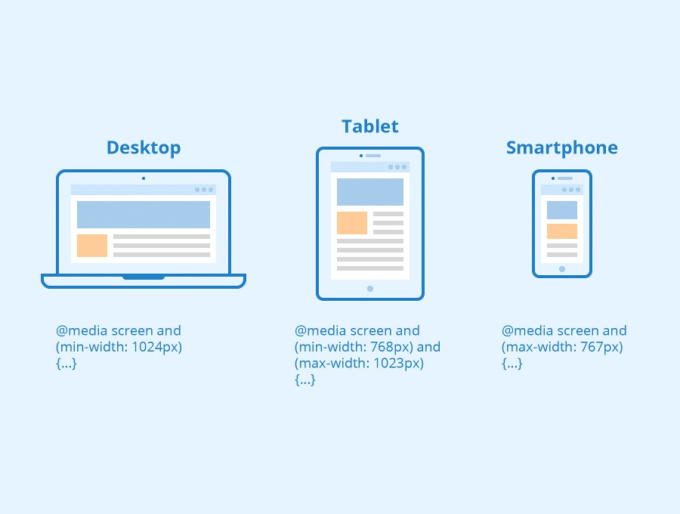

* **What is the rule set?**
* A rule set is a collection of one or many rules that are executed together as a single unit against a specific set of records.
* These rules are the default rules that are set by editor of the program and made a rule set.
* **Create image gallery using display grid with responsive.**
* GitHub Link for Responsive grid:

[**https://github.com/Avdheshpatel01/ASSIGNMENTS_TOPS/tree/main/CSS/Module_4_Grid-Responsive**](https://github.com/Avdheshpatel01/ASSIGNMENTS_TOPS/tree/main/CSS/Module_4_Grid-Responsive)

* Note: Prefer chrome browser.
* **Create below example with the help of clip path.**
* GitHub Link for Clip path:

[**https://github.com/Avdheshpatel01/ASSIGNMENTS_TOPS/tree/main/CSS/Module_4_TaskHeader**](https://github.com/Avdheshpatel01/ASSIGNMENTS_TOPS/tree/main/CSS/Module_4_TaskHeader)

* Note: Hover effects – given.
* **Multiple background one side bg-color other side contain image as bg.**
* GitHub Link for Multiple background:

[**https://github.com/Avdheshpatel01/ASSIGNMENTS_TOPS/tree/main/CSS/Module_4_Services**](https://github.com/Avdheshpatel01/ASSIGNMENTS_TOPS/tree/main/CSS/Module_4_Services)

* **Create below example using css waves generator.**
* GitHub Link for Team info.:

[**https://github.com/Avdheshpatel01/ASSIGNMENTS_TOPS/tree/main/CSS/Module_4_Waves**](https://github.com/Avdheshpatel01/ASSIGNMENTS_TOPS/tree/main/CSS/Module_4_Waves)

* Note: Hover effects – given.
* **Create Layouts.**
* GitHub Link for Layouts:

[**https://github.com/Avdheshpatel01/ASSIGNMENTS_TOPS/tree/main/CSS/Module_4_Layouts**](https://github.com/Avdheshpatel01/ASSIGNMENTS_TOPS/tree/main/CSS/Module_4_Layouts)

* **Create below example responsive media query.**
* GitHub Link for Responsive Web Page:

[**https://github.com/Avdheshpatel01/ASSIGNMENTS_TOPS/tree/main/CSS/Module_4_ResponsiveWebPage1**](https://github.com/Avdheshpatel01/ASSIGNMENTS_TOPS/tree/main/CSS/Module_4_ResponsiveWebPage1)

* Note: Use “Pixel 7” as reference device for responsive media query in inspect mode as this web page was designed as per this device’s size and ratio.
* Note: Hover effects – given (In both).